**Architecture for IoT project.**

**Reference block diagram:**

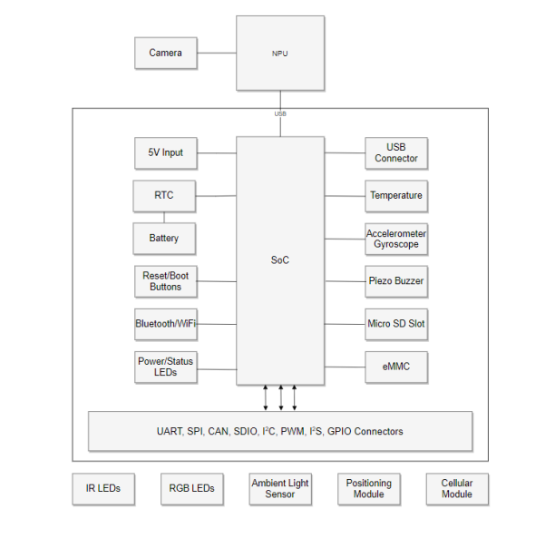

**Software drivers need to be implemented:**

1. RTC (I2C)
2. Temperature sensor (I2C)
3. Accelerometerter/Gyroscope module (I2C)
4. Ambient light sensors (I2C)
5. Positioning modules – GPS (I2C)
6. Wifi module (UART)
7. GSM module (Cellular) – (UART).
8. Buzzer (GPIO)
9. Micro SD card (SPI)
10. IR LEDs (PWM)
11. RGB LEDS (PWM)
12. USB
13. I2S
14. CAN
15. SDIO
16. Parent Class: I2C

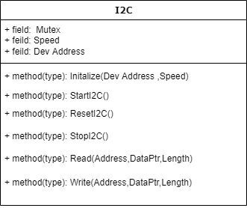

* All functions are guarded by mutex locks.
  1. Child class: RTC

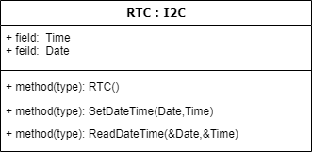

* 1. Child class : Gyro

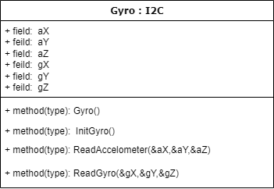

* 1. Child class : LightSensor

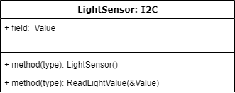

* 1. Child class : GPS

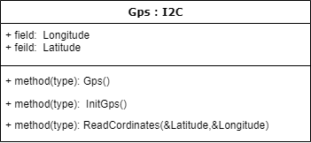

1. Parent Class: UART

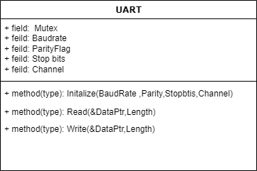

1. Child class : Gsm

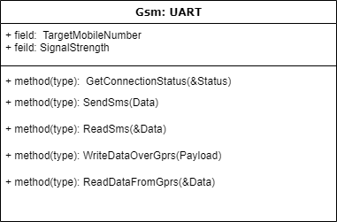

1. Parent class: GPIO

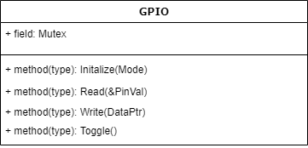

1. Parent class: SPI

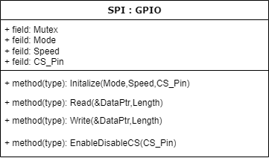

1. Child class : SD_Card

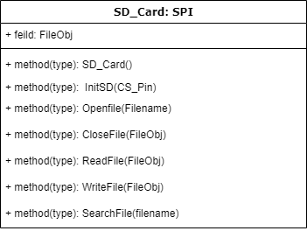

1. Parent class: PWM

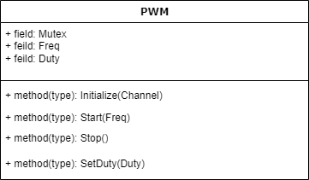

1. Child class : IR_LED

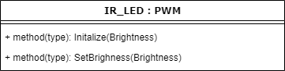

1. Child class : RGB_LED

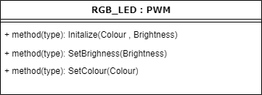

1. Class Wifi

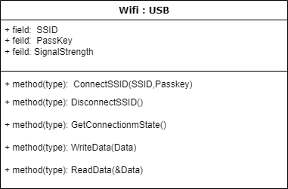

**Handler for MQTT connection**

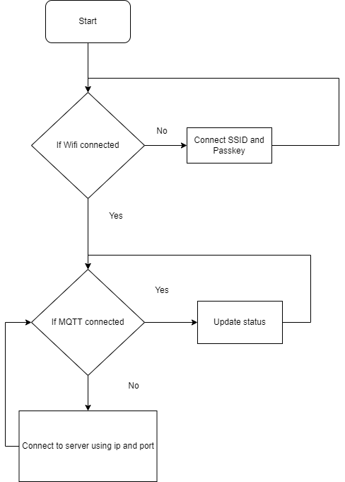

**Fetching sensor parameters, Saving and Sending data to a cloud**

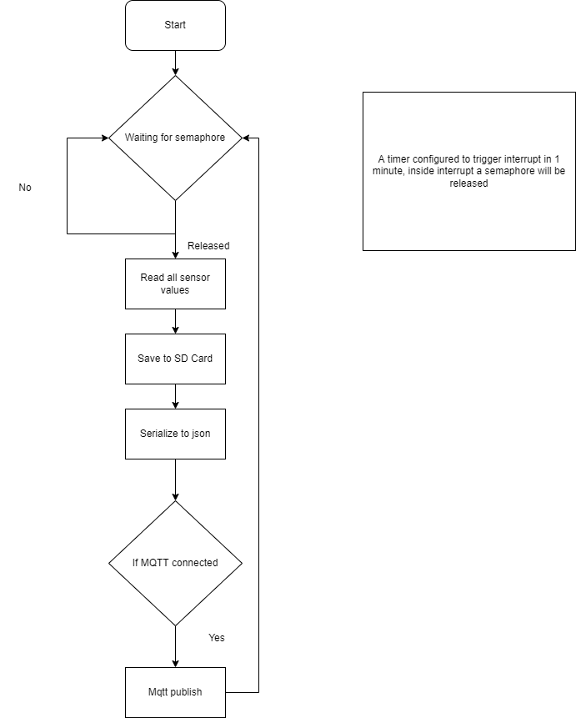

**Communication between application to Mobile APP.**

For ease of communication, we are using Google remote procedure calls (GRPC) over TCP IP.

Using gRPC a client app can directly call a method in the server app. Hence all parameters can be read from server directly.

